Recording Video

1. Turn camera on
2. Open Quicktime on computer
3. In Quicktime: Choose **File** → **New Movie Recording**

* Smile! A window will open up showing the webcam view.
* To change the view to the camera: Click on the **small arrow** next to the record button and choose **USB Camera**
* Now you should see the microscope camera view.

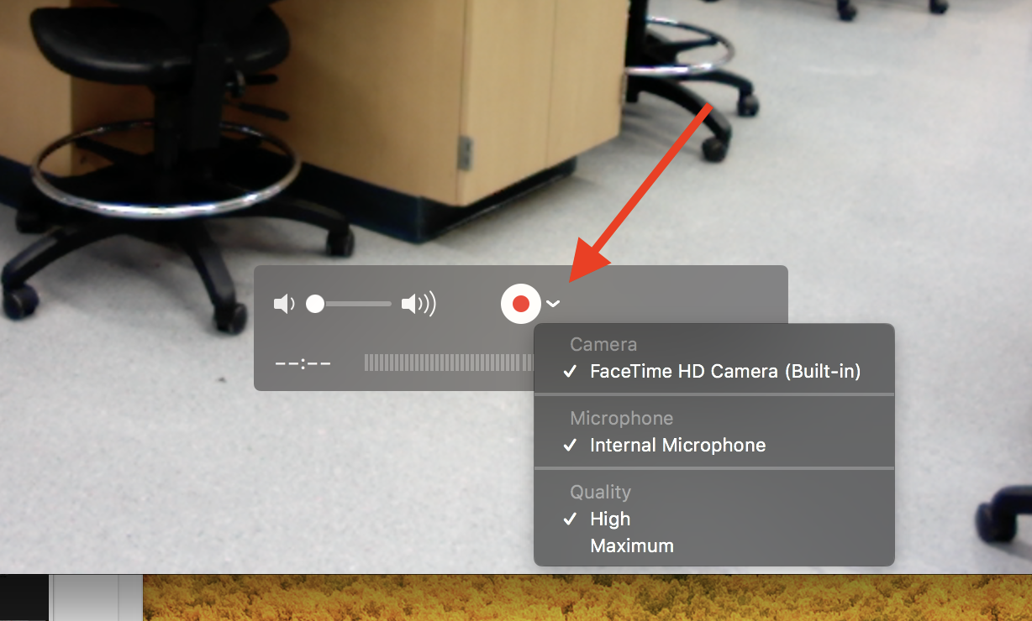

1. Use the **record button** to start/stop filming
2. To save a video: Go to **File** →**Save…**

**\*\*Reference the Quicktime manual for more instructions on how to trim videos in quicktime. Or you can edit them in iMovie.**

Import Video to iMovie

1. Open iMovie
2. Click the Create New Box and select Movie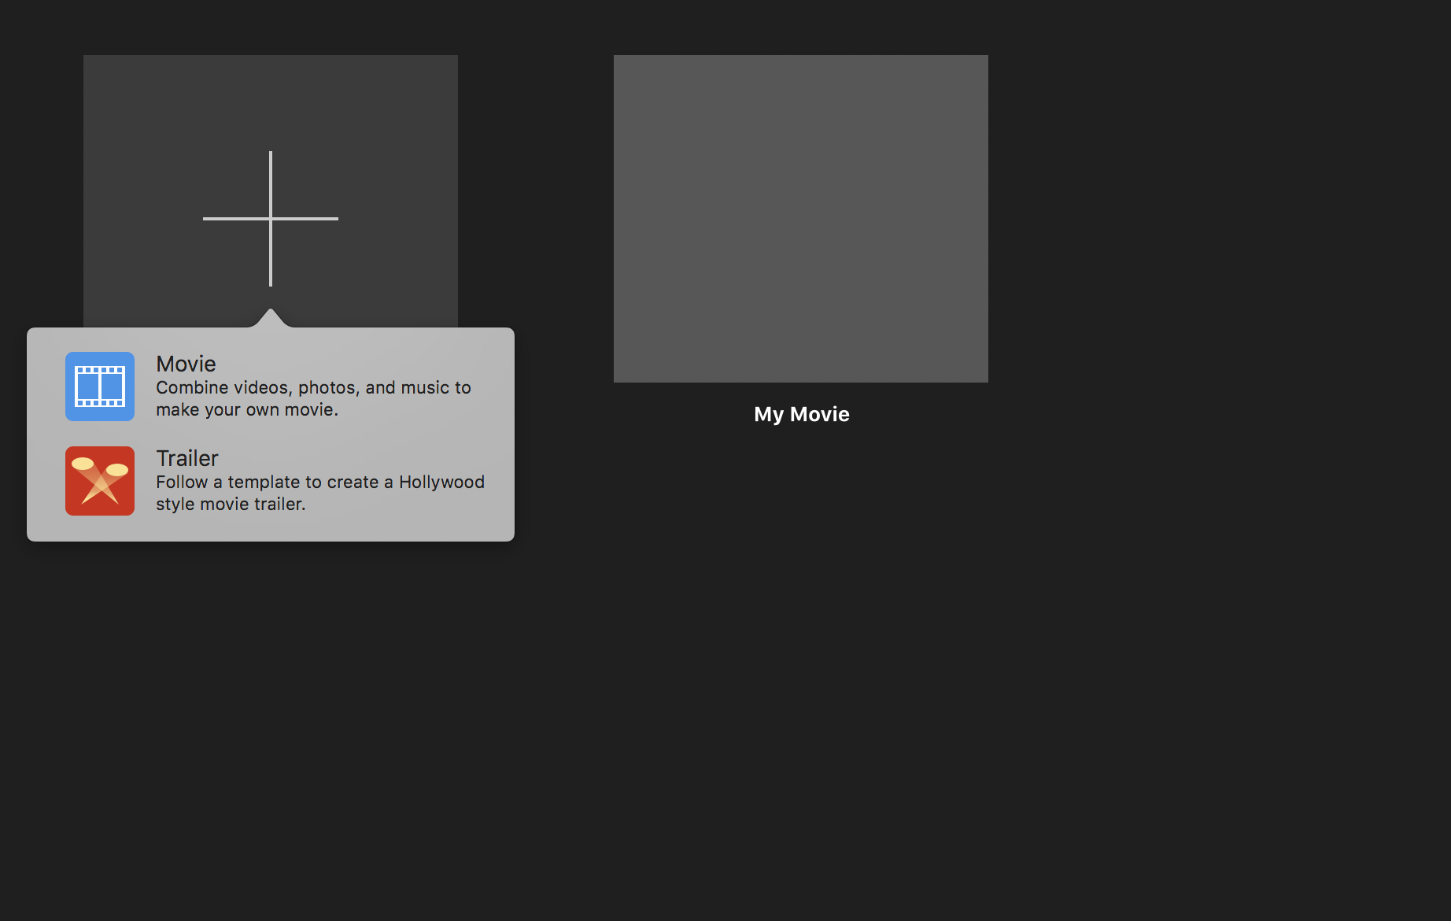
3. 2 Options to upload videos saved on computer:
   1. Top left there is a **down arrow button** next to the min/max/close buttons

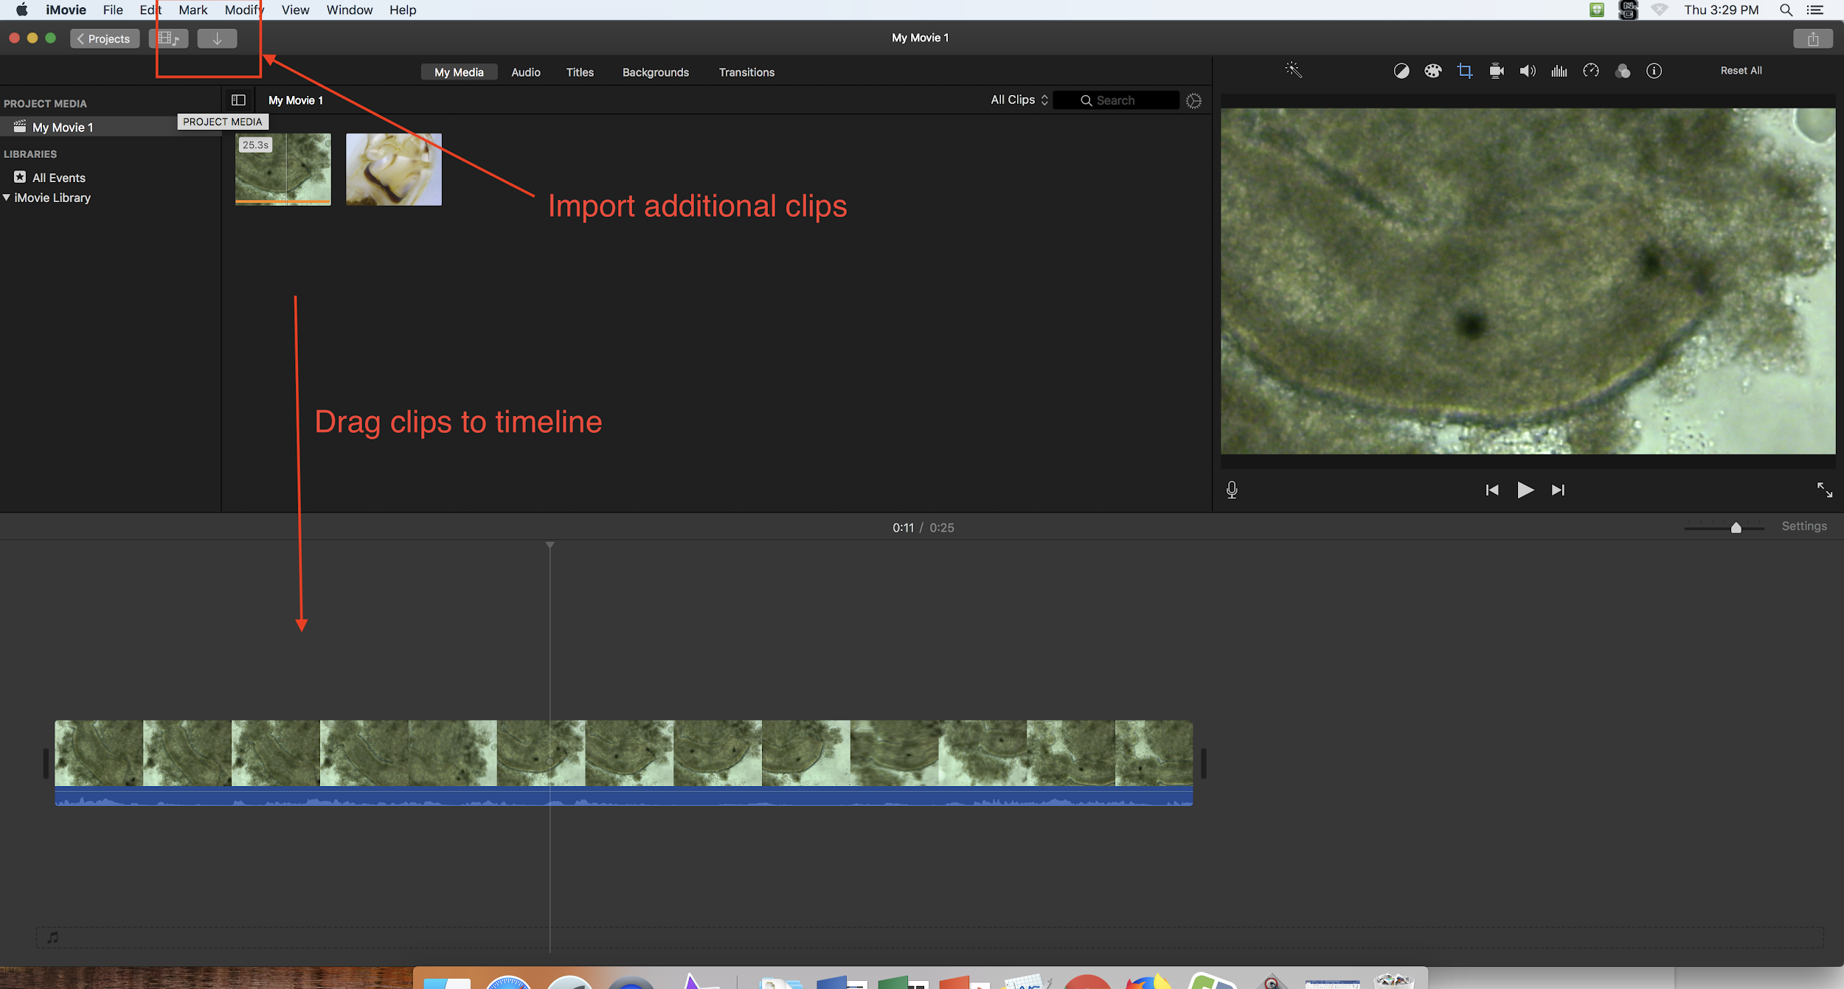

* 1. Go to **file** → Import **Media…** → **Choose your video**

**You can upload multiple videos to a single movie. Just Drag the clips down to the timeline and organize

To trim a clip: Select the clip on your timeline that you want to edit.

* 1. To shorten the clip from the end, you can simply drag it backwards.
  2. To trim the beginning, move the mouse to the place where you would like the clip to start → Control Click on the circle on the vertical line → Choose **Split Clip**. This splits the clip into two. Now select the part that you do not want and hit delete.

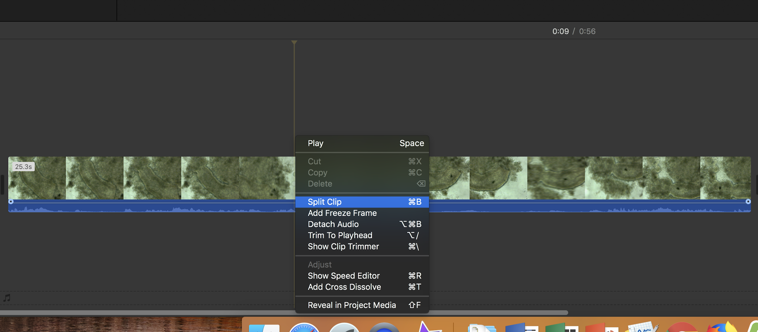

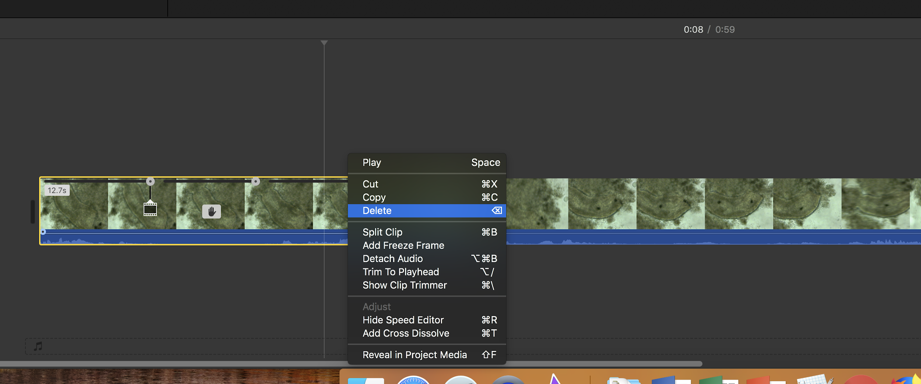

It will be helpful to adjust the lighting on your clips

1. In the top right above your preview screen there is a toolbar.
2. Select the **color balance icon** and choose **White Balance**
3. Click on the screen with the dropper to change the color balance
4. Be sure to **click on the check mark in top right** to save your adjustment!!

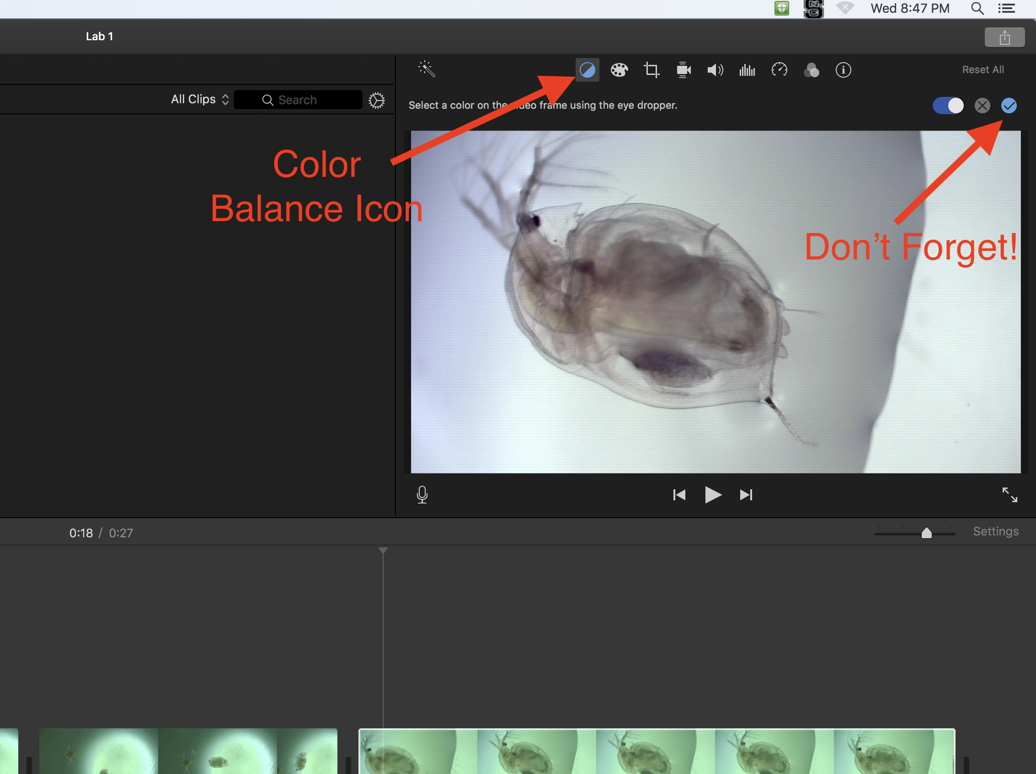

If you would like to label/title a clip within a movie: Go to the titles tab at the top of screen

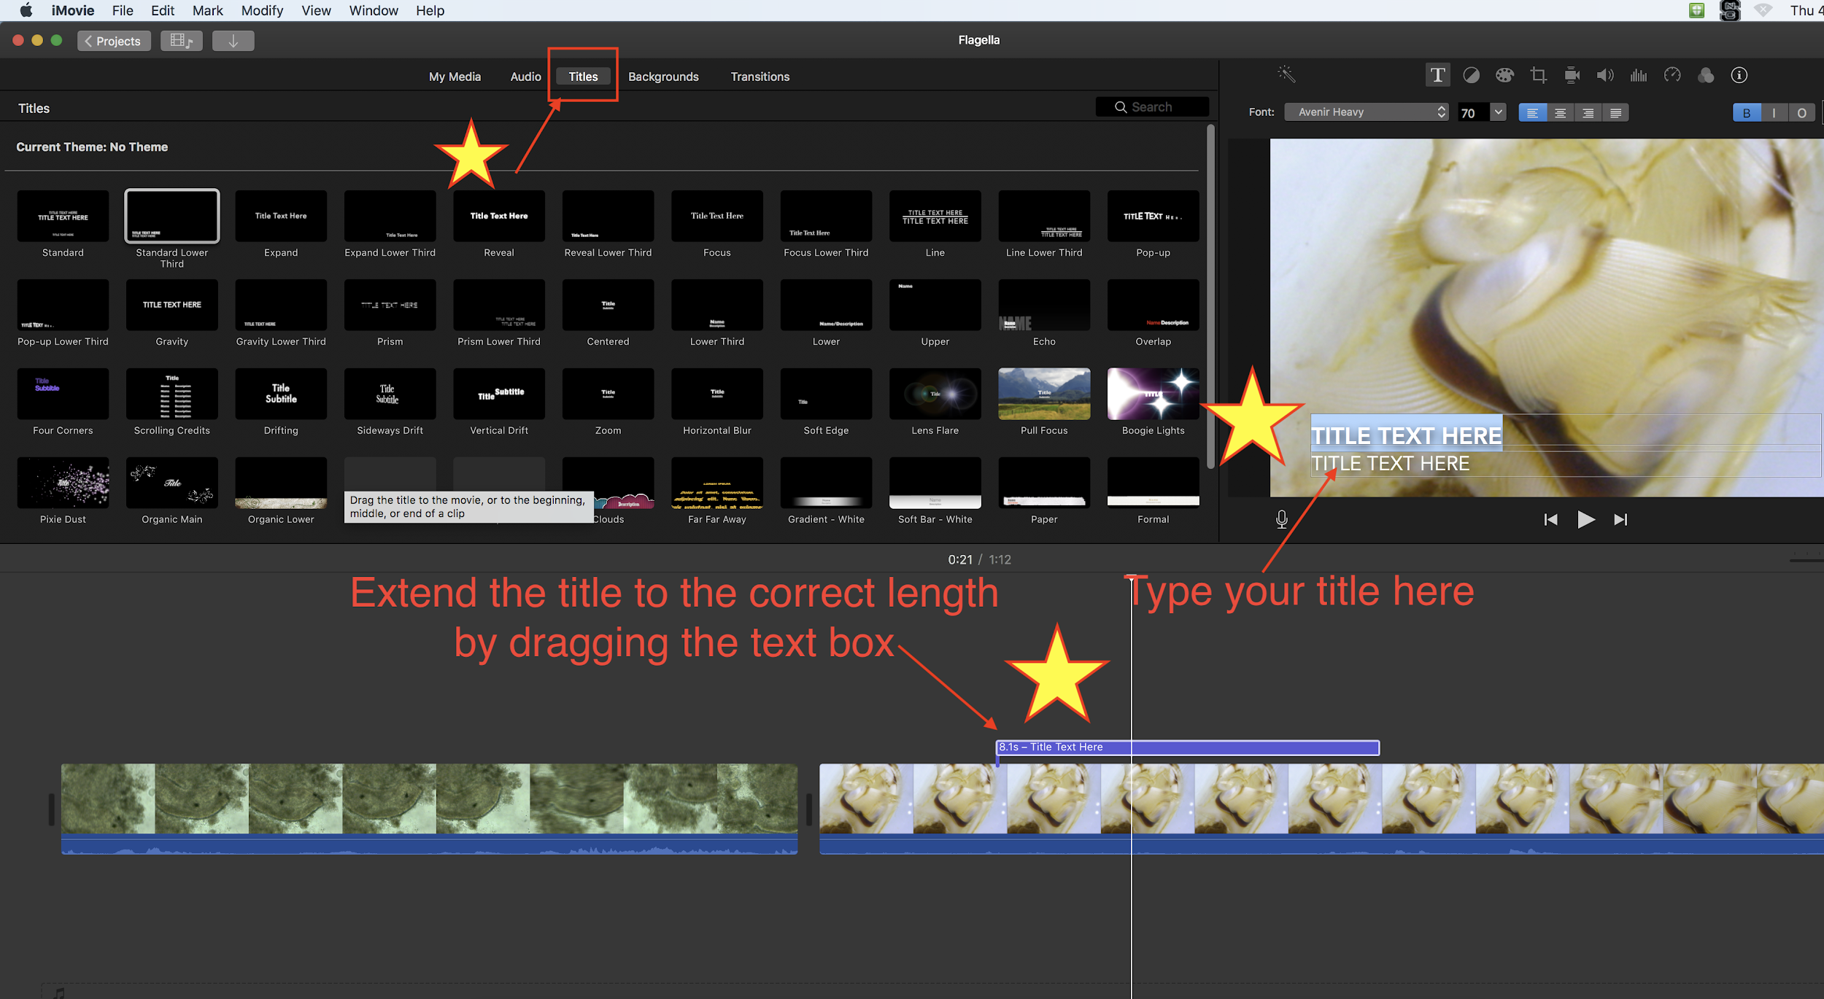

**Don’t forget to rename each project/movie and save to your folder!!**

Your movie will save in iMovie, you can rename each project under the projects tab

To save your movie to your desktop folder:

You can select individual clips or the project as a whole

1. Go to **File → Share → File…**
2. Click **next** on the window that pops up
3. Name the movie/clip and move it to your appropriate folder

Pictures:

Some students will prefer to obtain their pics from their short video. You can pause a video and do a screen shot.

You can take screenshots of anything on the computer by hitting: **command + shift + 4**

* You can then use the cursor to drag and select the area you wish to screenshot
* When you release the cursor, the screenshot is automatically saved to the desktop
* Be sure to then rename it and move it to the correct folder

You can also take a screenshot straight from the preview app:

This method can be very frustrating as you suddenly realize how out of focus each one of the “shots” that you eye sees as a composite can be. It would be better to do a screen capture outside of iMovie or QuickTime. Skim the manual detailing preview instructions.